Lab- Enterprise Application

**Add an enterprise application**

To add an enterprise application to your tenant:

1. Go to the [Azure Active Directory Admin Center](https://aad.portal.azure.com/) and sign in using one of the roles listed in the prerequisites.
2. In the left menu, select **Enterprise applications**. The **All applications** pane opens and displays a list of the applications in your Azure AD tenant.
3. In the **Enterprise applications** pane, select **New application**.
4. The **Browse Azure AD Gallery** pane opens and displays tiles for cloud platforms, on-premises applications, and featured applications. Applications listed in the **Featured applications** section have icons indicating whether they support federated single sign-on (SSO) and provisioning. Search for and select the application. In this quickstart, **Azure AD SAML Toolkit** is being used.

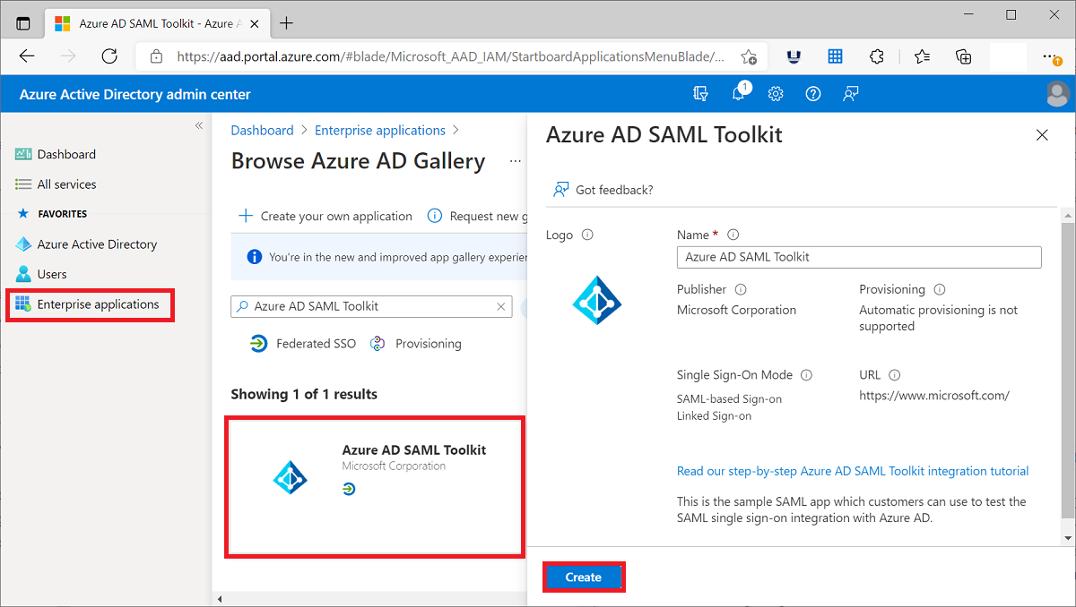

1. Enter a name that you want to use to recognize the instance of the application. For example, Azure AD SAML Toolkit 1.
2. Select **Create**.

**Create a user account**

To create a user account in your Azure AD tenant:

1. Go to the [Azure Active Directory Admin Center](https://aad.portal.azure.com/) and sign in using one of the roles listed in the prerequisites.
2. In the left menu, select **Users**.
3. Select **New user** at the top of the pane.

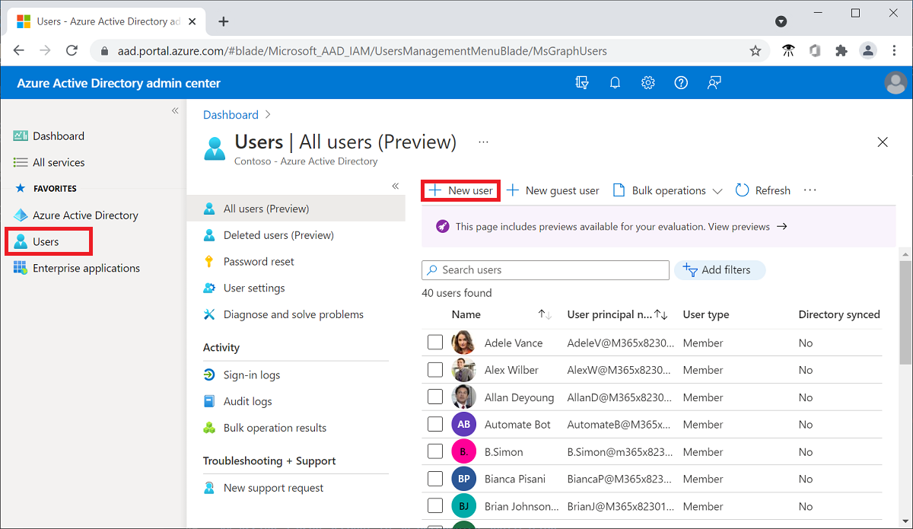

1. In the **User name** field, enter the username of the user account. For example, contosouser1@contoso.com. Be sure to change contoso.com to the name of your tenant domain.
2. In the **Name** field, enter the name of the user of the account. For example, contosouser1.
3. Leave **Auto-generate password** selected, and then select **Show password**. Write down the value that's displayed in the Password box.
4. Select **Create**.

**Assign a user account to an enterprise application**

To assign a user account to an enterprise application:

1. In the [Azure Active Directory Admin Center](https://aad.portal.azure.com/), select **Enterprise applications**, and then search for and select the application to which you want to assign the user account. For example, the application that you created in the previous quickstart named **Azure AD SAML Toolkit 1**.
2. In the left pane, select **Users and groups**, and then select **Add user/group**.

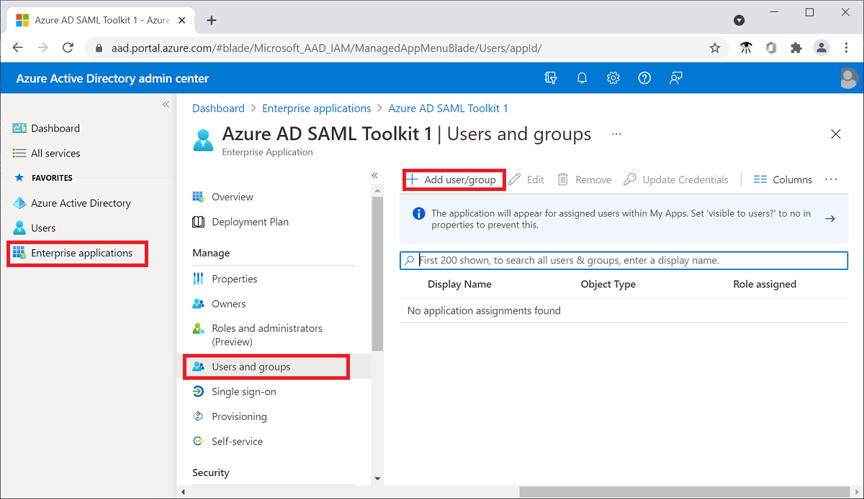

1. On the **Add Assignment** pane, select **None Selected** under **Users and groups**.
2. Search for and select the user that you want to assign to the application. For example, contosouser1@contoso.com.
3. Select **Select**.
4. On the **Add Assignment** pane, select **Assign** at the bottom of the pane